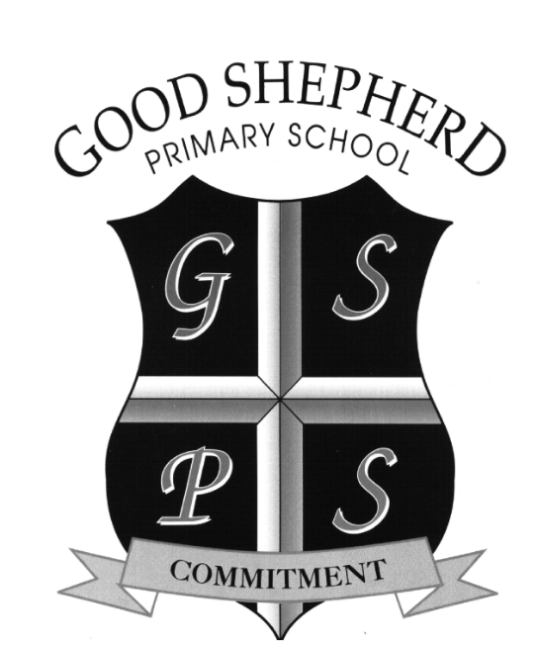

Tuesday 30th June 2020

Dear Parents,

As we bring this extraordinary school year to a close I wish to firstly thank you for your on-going cooperation and offer you some information about the way things might look in the new school year. As I’m sure you are aware, there has been much speculation in media circles about how schools might organise the return to classes after the summer break.

I am going to concentrate for now on what is certain and I will update you by means of a letter which I will post on the school website and I will direct you to via text message on Tuesday 11th August 2020.

**Dates for return to school**

The school will open from **Monday 24th August 2020** for those children who:

* are going into **Primary 7**
* are already attending **Social Communication Classes**
* have been attending our **Nurture Class** (now going in to Primary 2)

Times for these school days will be confirmed on Tuesday 11th August 2020

The school will be open on **Tuesday 1st September** **2020** for

* Children in Primaries 2-7 (initially this may be for a shorter school day – more information regarding this on Tuesday 11th August)

*Based on current Social Distancing guidance we may have to split the days into morning and afternoon groups from Monday – Thursday only, but this will also be confirmed on Tuesday 11th August 2020. Where this is this is the case we will be keeping family groups together.*

The parents of **Primary 1** children will receive their letters and information packs in mid-August which will contain their starting date details.

**School Uniform**

In order to ensure that all children are in a position to wear fresh, clean clothes each day, we are recommending that for the initial stage of the new term, **children will not be required to wear school uniform.** If you have already purchased some or all of your child’s uniform, please do not worry as uniforms will be required later in the school year.

As you can probably imagine, there is still some decision making to be completed before a return to school in August and September. I will continue to keep you updated as and when these decisions have been ratified by the Board of Governors.

Thanks for your understanding,

Mr. D. O’Neill

School Principal